Lab1 Spice Simulation of Setup Time Estimation
Name: Student ID:
Corner | Voltage (V) | T_{qcq} (ps) | T_{setup} (ps)
tt | 1.8
tt | 1.98
tt | 1.62
ff | 1.8
ff | 1.98
ff | 1.62
ss | 1.8
ss | 1.98
ss | 1.62
fs | 1.8
fs | 1.98
fs | 1.62
sf | 1.8
sf | 1.98
sf | 1.62

Please paste the waveform and the screenshot of the measurement result
(15 sets of screenshot)
- tt corner & 1.8V (please remove the example screanshots)
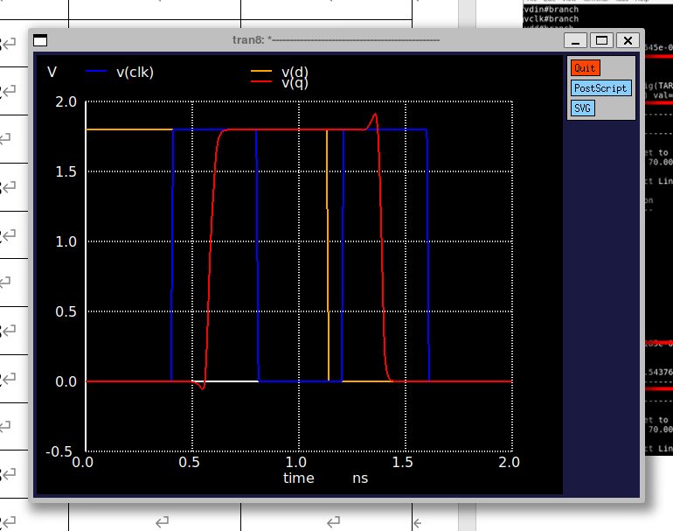
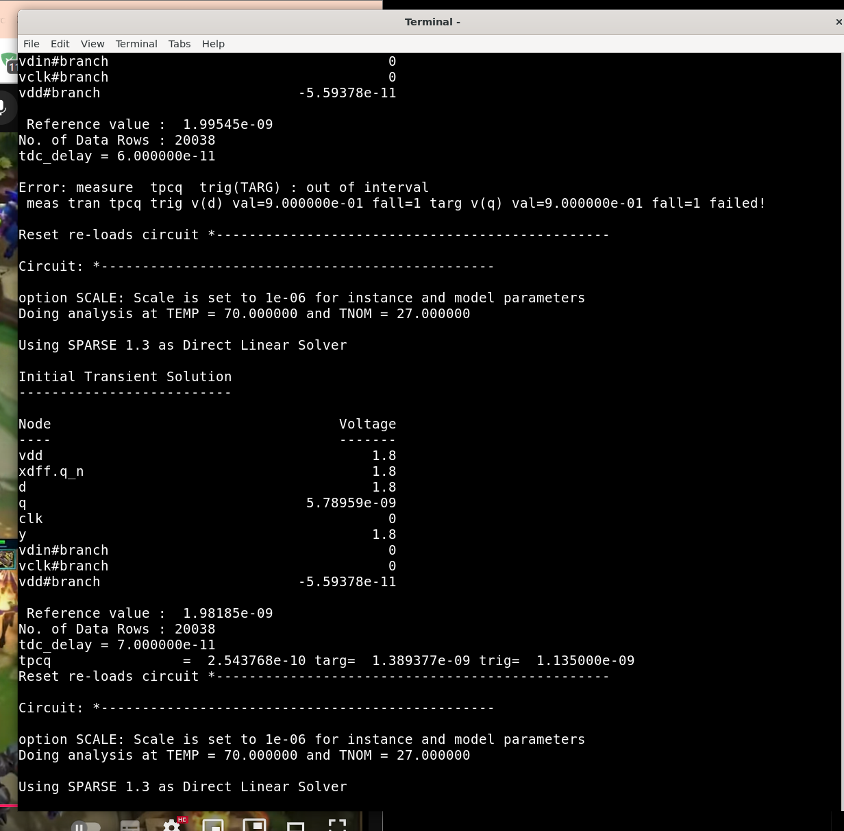
- tt corner & 1.98V
- tt corner & 1.62V
- ff corner & 1.8V
- ff corner & 1.98V
- ff corner & 1.62V
- ss corner & 1.8V
- ss corner & 1.98V
- ss corner & 1.62V
- fs corner & 1.8V
- fs corner & 1.98V
- fs corner & 1.62V
- sf corner & 1.8V
- sf corner & 1.98V
- sf corner & 1.62V
Questions:
- In your observation, what is the sky130_fd_sc_hd__dfxbp_1 setup time?
Answer:

- What is the impact of process corners and VDD variations on the DFF's timing and setup time?
Answer:

